Recipe application prog part 2

Read me file

Recipe Management Console Application

This is a console-based recipe management application written in C#. The application allows users to add, display, scale, and reset recipes. It also notifies users if the total calories of a recipe exceed 300 using event handling.

**Features**

- Add new recipes

- Display all recipes

- Scale recipe ingredient quantities

- Reset recipe ingredient quantities

- Notification if total calories exceed 300

**Getting Started**

**Usage**

Upon running the application, you will be presented with a menu of commands:

**Commands:**

1. Add Recipe

2. Display All Recipes

3. Scale Recipe

4. Reset Quantities

5. Exit

**Commands**

**1. Add Recipe**

This command allows you to add a new recipe. You will be prompted to enter details for the recipe, including:

- Recipe name

- Ingredients (name, quantity, unit, calories, food group)

- Steps (description)

**2. Display All Recipes**

This command displays all recipes in alphabetical order. You can then select a recipe to view its details, including ingredients, steps, and total calories.

**3. Scale Recipe**

This command allows you to scale the quantities of ingredients in a recipe by a given factor. You will be prompted to enter the name of the recipe and the scaling factor.

**4. Reset Quantities**

This command allows you to reset the quantities of ingredients in a recipe to their original values. You will be prompted to enter the name of the recipe.

**5. Exit**

This command exits the application.

**Event Handling**

If the total calories of a recipe exceed 300, a warning message will be displayed. This is handled using an event and a delegate.

**Code Overview**

**Main Program**

The `Program` class contains the main loop of the application, which presents the menu and handles user input.

**RecipeManager Class**

The `RecipeManager` class manages the list of recipes and handles operations related to adding, displaying, scaling, and resetting recipes. It also contains an event for notifying when a recipe's total calories exceed 300.

**Recipe Class**

The `Recipe` class represents a recipe, containing properties for the name, ingredients, and steps. It includes methods for entering ingredients, entering steps, displaying the recipe, scaling ingredients, and resetting quantities.

**Ingredient Class**

The `Ingredient` class represents an ingredient with properties for the name, quantity, unit, calories, and food group.

**Step Class**

The `Step` class represents a step in the recipe with a description.

**Code Screen Shots**

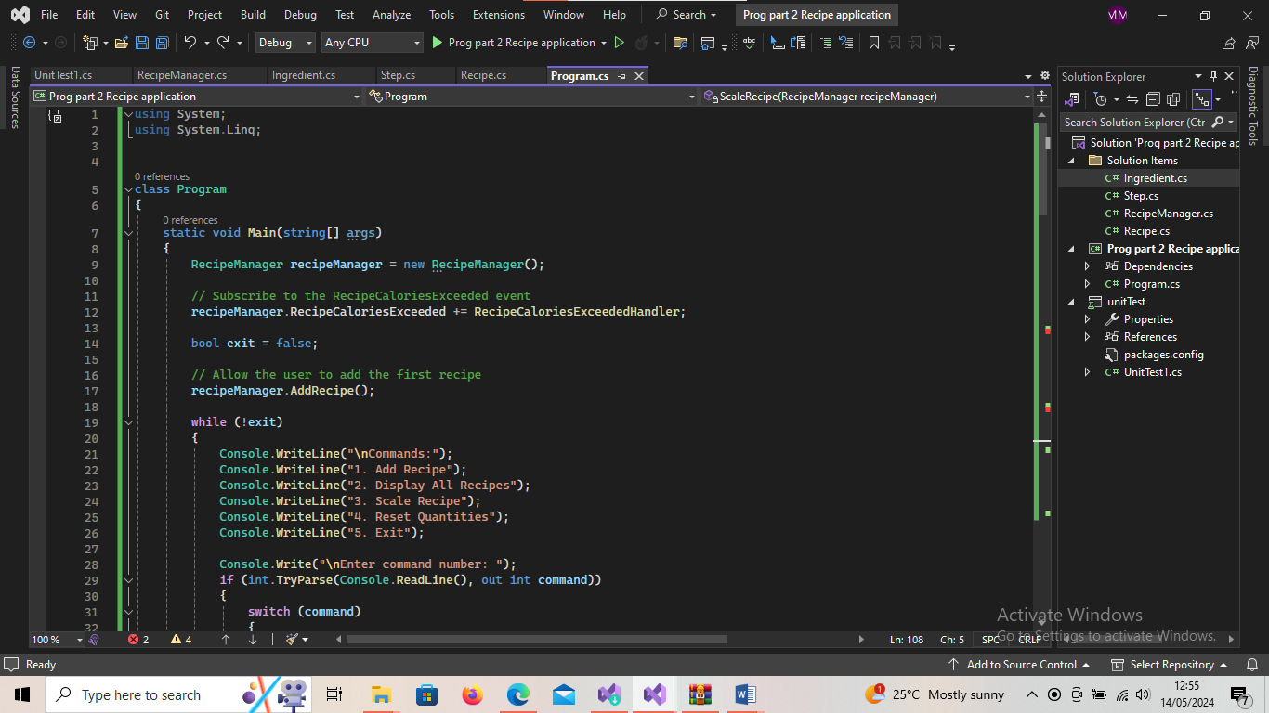

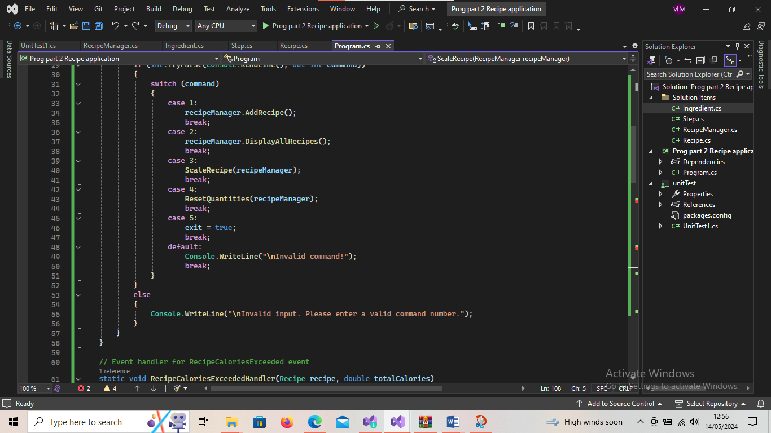

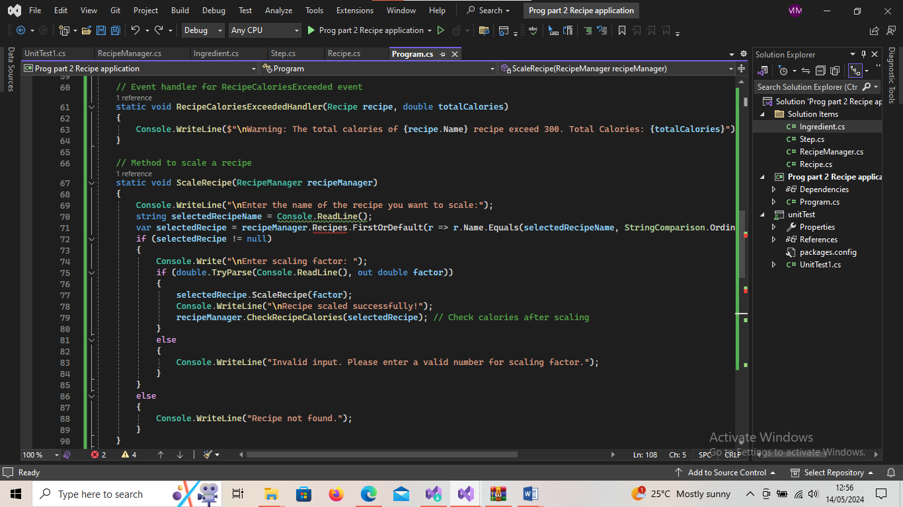

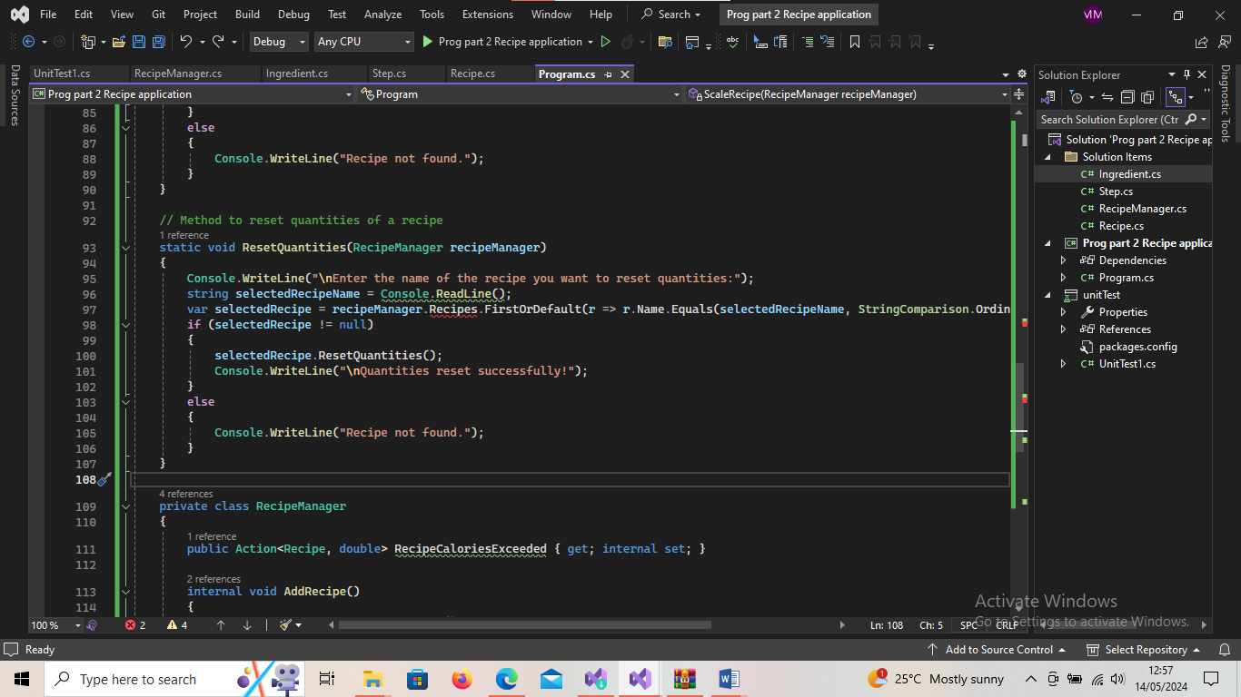

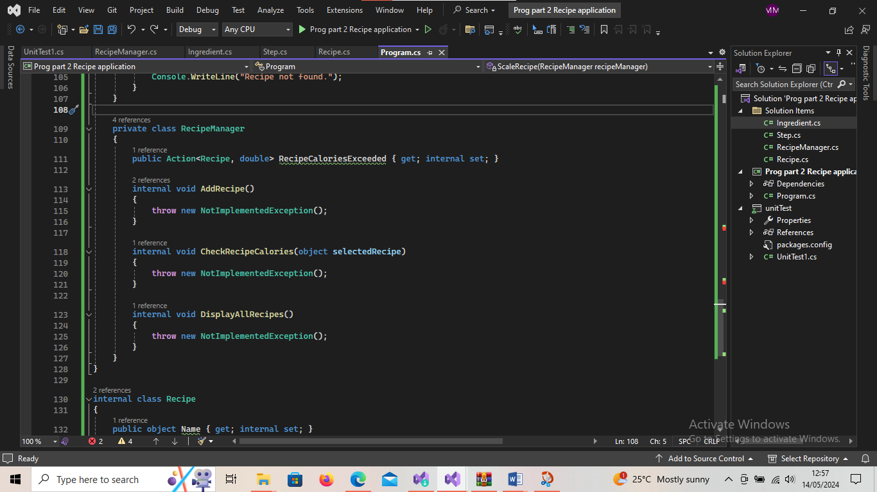

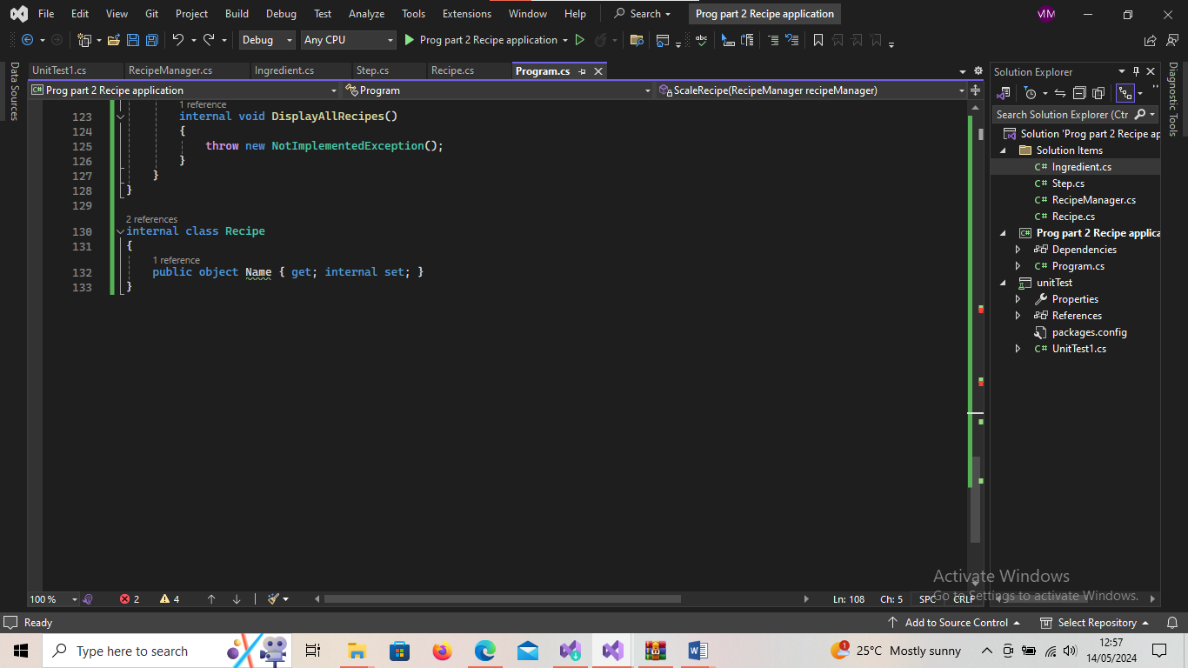

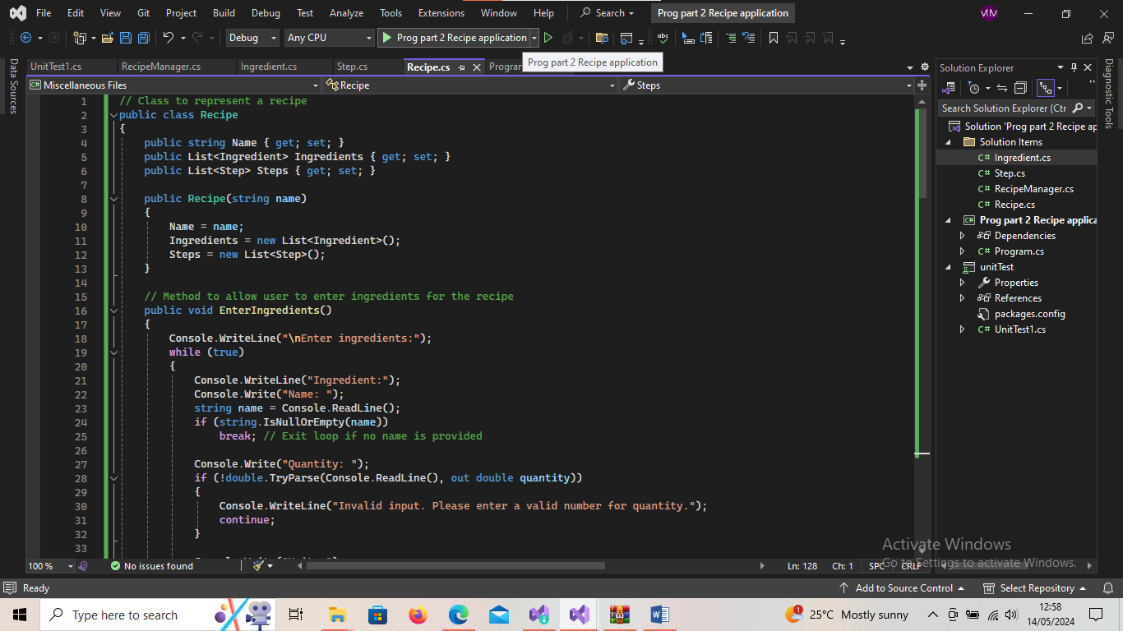

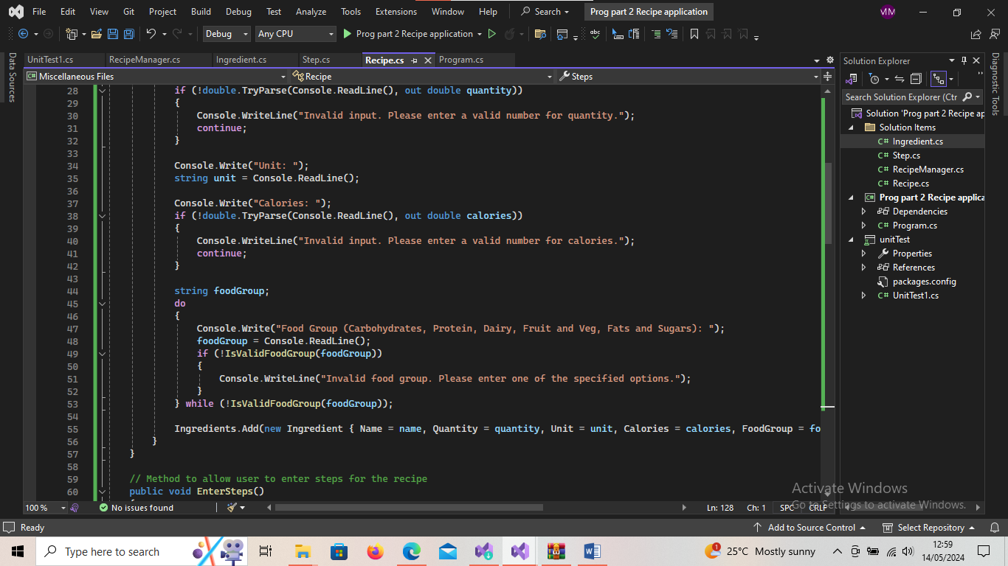

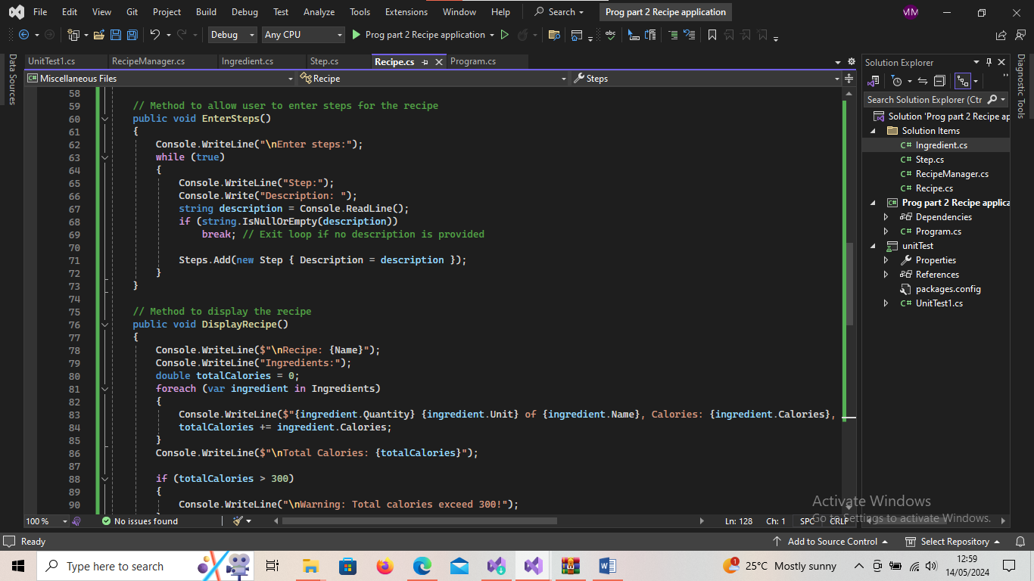

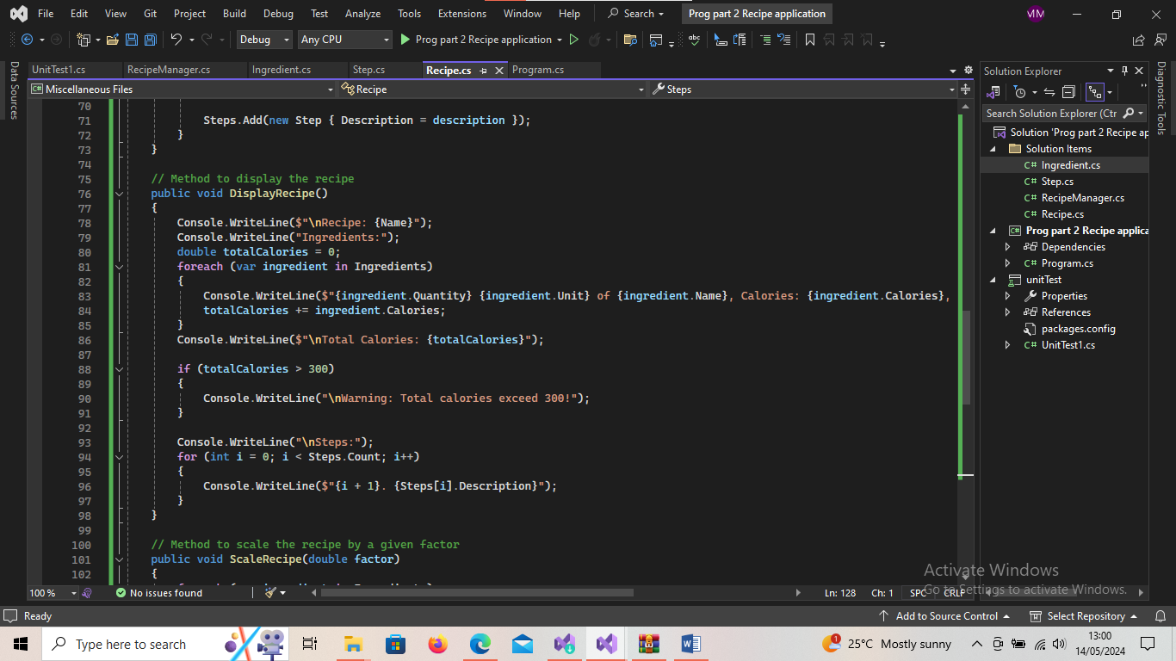

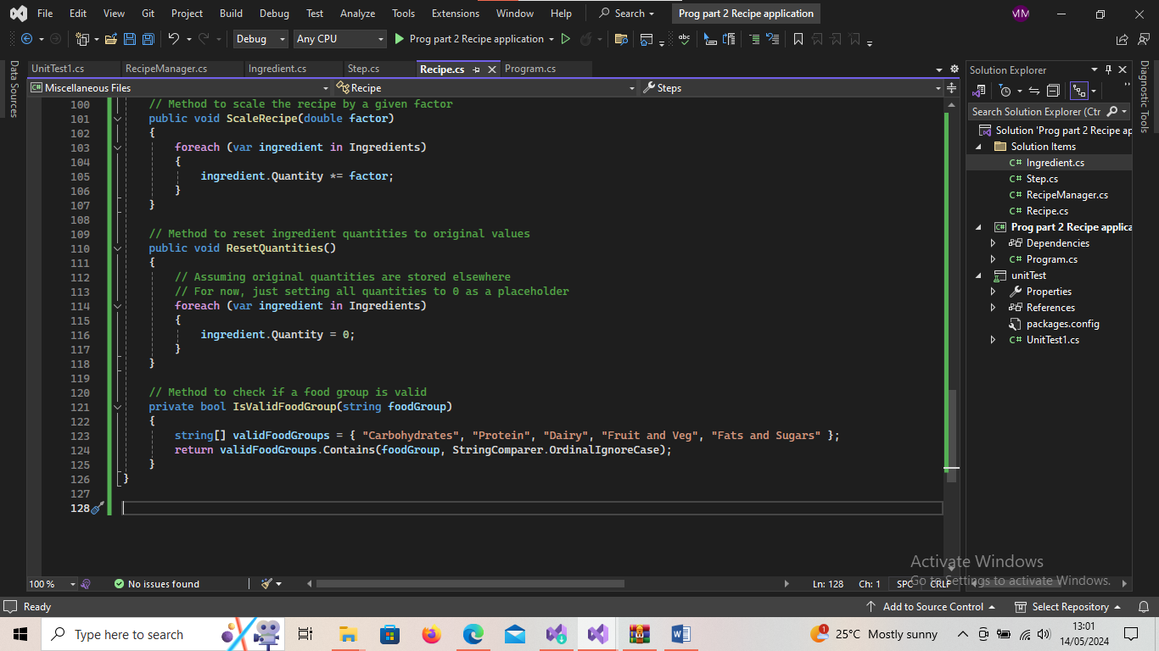

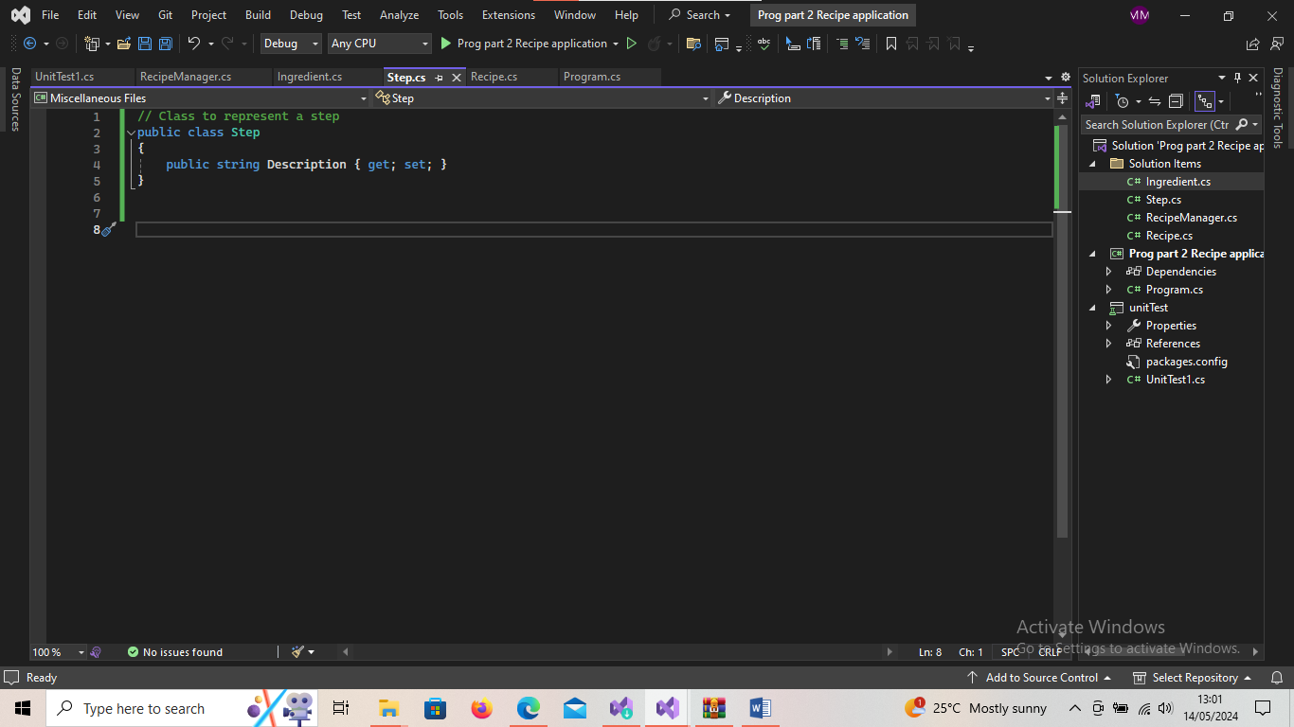

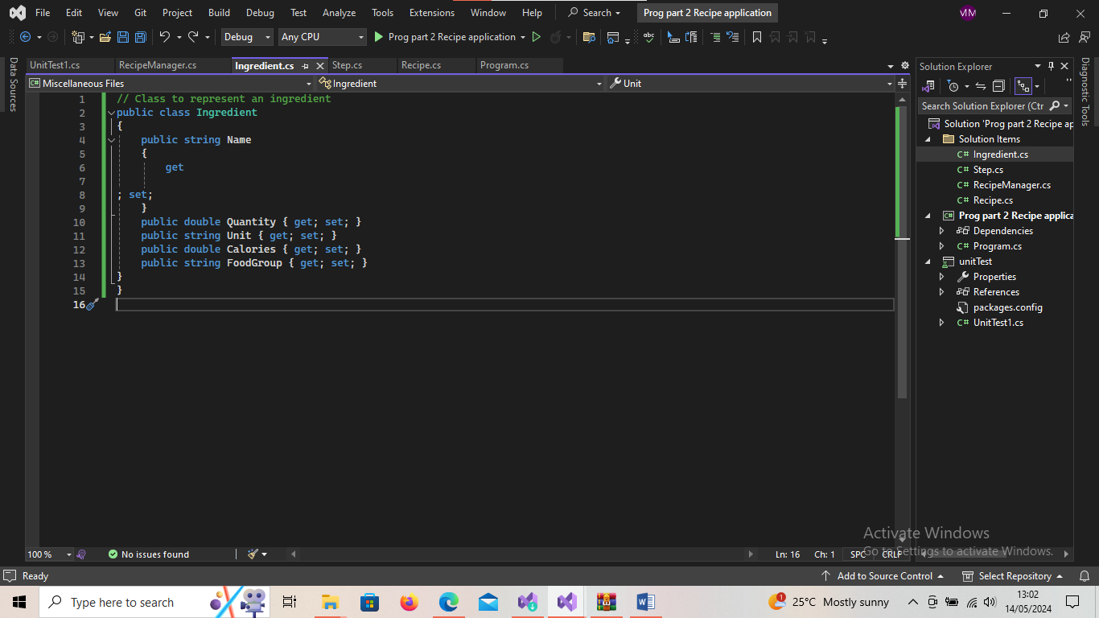

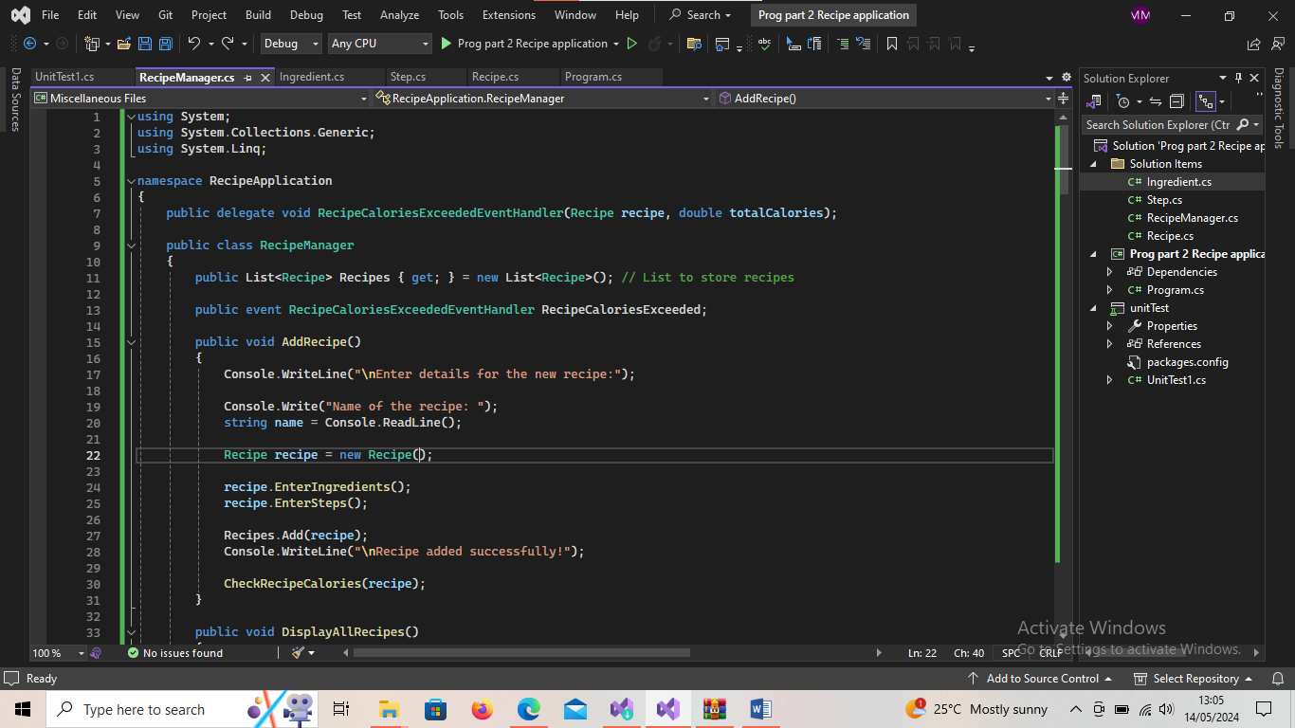

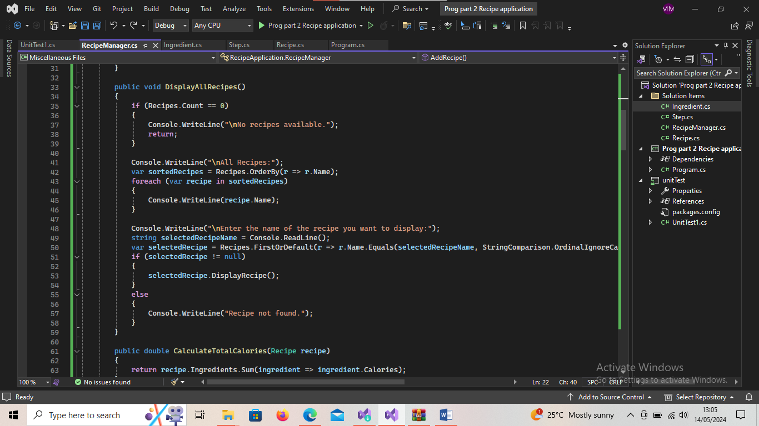

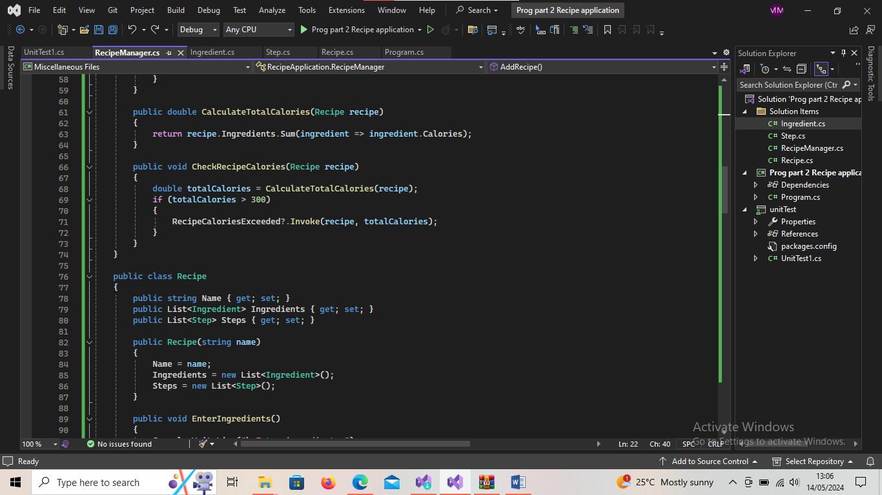

**6**